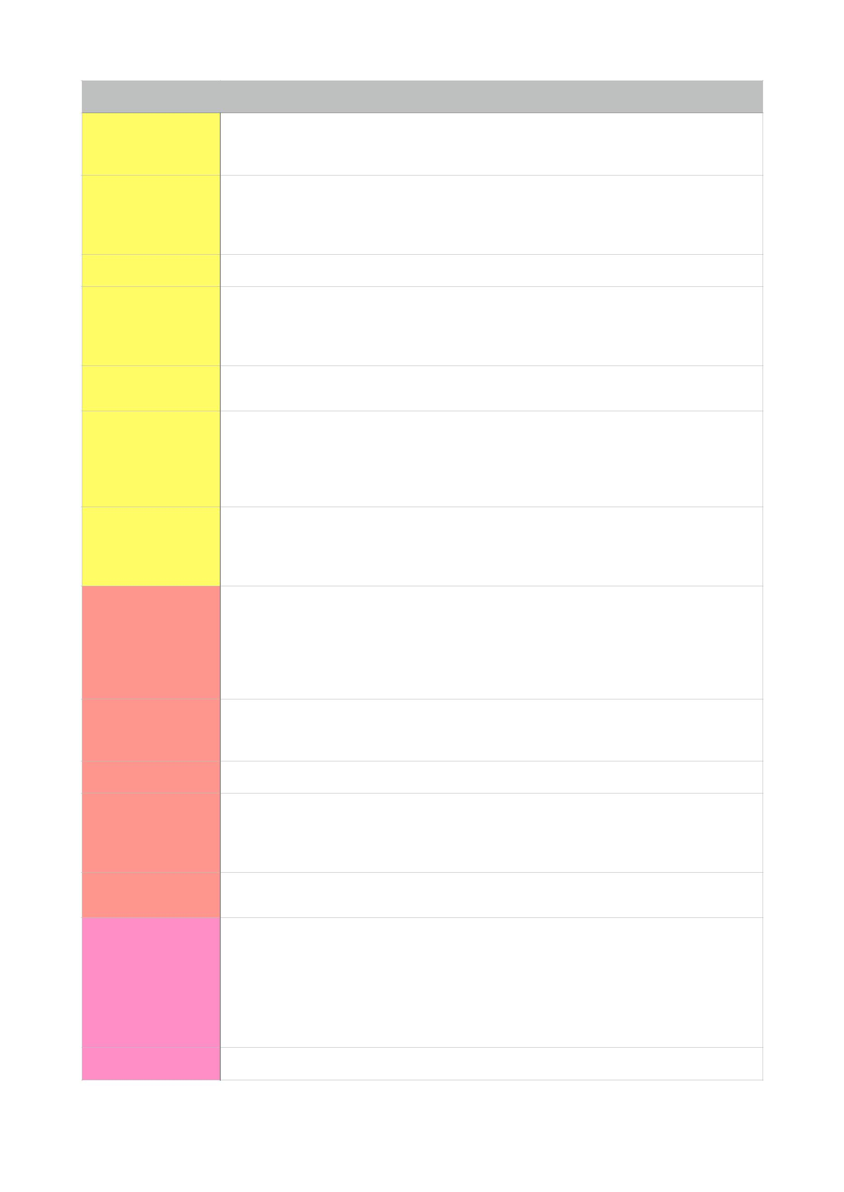

1.05.L01 |  | What makes a conversation enjoyable?What makes a conversation frustrating?What’s your deﬁnition of a good conversation?
1.06.01 What’s your opinion:

Do women talk more than men?

Do women communicate better than men?

Is a conversation between 2 men diﬀerent from one between 2 women?
1.08.SL01 What are common complaints girlfriends and boyfriends make about each other?
1.10.S02 In what kind of situation is it diﬃcult not to overhear another person’s private
conversation? How do you feel when that happens?
Describe a conversation you overheard? Did they notice?

Who would like to eavesdrop on? What do you imagine them saying?
1.11.05 When was the last time you had to make an excuse because you were late or had
forgotten to do something? What did you say? Did the other person believe you?
1.12.01 How would you:
start a conversation with someone you don’t know at a party?
introduce yourself to a new student?
start a conversation with someone you haven’t seen for a long time? speak to the person sitting next to you on a train or a bus?
1.12.07 How would you start a conversation about:
something that’s been on TV recently?
an item of clothing or an accessory your partner is wearing? something that really annoys you?
2.14.S01.L01 If you were a food, what food would you be and why?
What food would you associate with:
being in love?
waiting at the train station?
summer?
your grandparents’ house?
2.19.Speaking Tell me about the time you ate out at a restaurant!
When? Where? With whom? Why go there? What was it like? Atmosphere? What
did you eat? Enjoyable? Service? Would you recommend it?
2.20.L02b Do you have a favourite foreign dish? What is it? What are the ingredients?
2.21.04/05 Are these acceptable?
chewing gum kissing in public spitting on the street losing your temper in public
Would your parents have the same opinion? What other things are not in good
taste?
2.23.01 Do you like wearing jeans? Would you wear them to work? An interview? Explain
why?
3.25.04 Opinion?
Most young people prefer to live in larger cities! Older people living alone can feel lonely in big cities!
People living in the country are generally more healthy than city dwellers!
Life in the country is less stimulating than in a big city!
There is far less violent crime in the country! People suﬀer from sleep deprivation in big cities!
3.26.b Which capital would you like to spend a weekend in? Explain why!
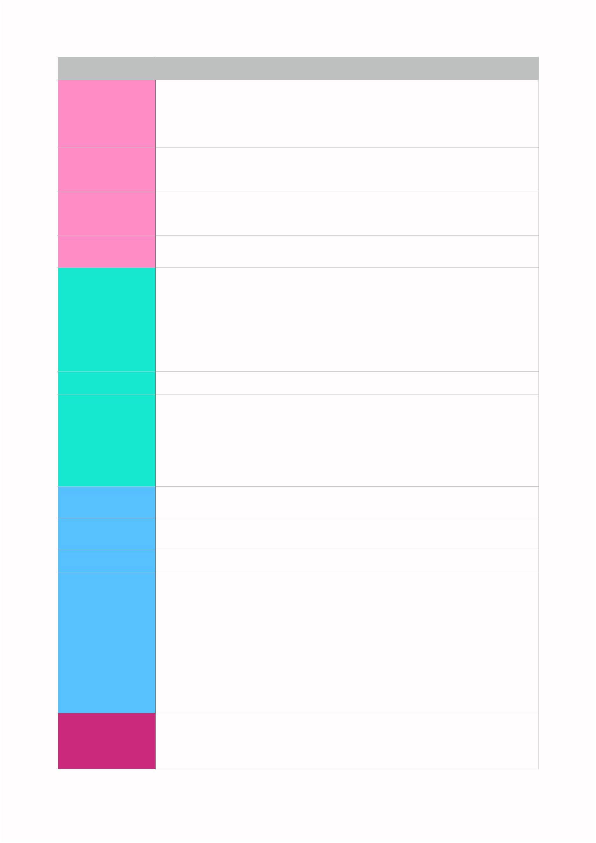
3.29.03 Which city attracts most visitors?
What is there for them to see and do?
What’s the best time to visit?
What do the advertising campaigns try to sell? Adjectives that sum up the city.
3.30.05 Where is the busiest place in the evening where you live?
What do people do there?
Do you like to go out in the evenings? Where do you go? What do you do?
3.31.S04 What advice would you give:
someone visiting your hometown for the ﬁrst time?
someone going abroad for the ﬁrst time?
3.32.06/07 Are there modern buildings in your town or country?
What do people think about them - when the ﬁrst went up/now?
4.39.Speaking What’s your favourite story? What kind of story is it?
Where and when did you read, hear or see it?
What is the story about?
Where and when is the story set?
Who are the characters?
What’s the plot?
What happens at the end? Why do you like it?
4.42.05b What sort of sense of humour do Chinese people have?
4.45.05 Tell me a childhood memory about:
your ﬁrst day at school
a time you got lost or got into trouble
a birthday or a time you got a special present
a visit, outing, holiday or celebration
a memorable meeting
the ﬁrst time you did something…cinema, zoo, dentist…
5.46.02 What type of shopper are you?
savvy spender, penny-pincher or credit card binger?
5.48.01 Could you live on ¥10 a day. What would you stop buying and what would you cut
back on?
5.49.04 How do you feel about bargaining? What are you experiences?
5.51.Speaking Talk about a purchase you have made recently
What did you decide to buy?
Impulse buy/shopping around? Who did you go with? Where did you look? What was it like? Was it expensive? How did you pay?
Were you pleased with it?
Do you use it still?
Was it a good purchase?
6.60.L01.a/b/c/g How many senses do we have?
Which do you think is the most important?
Which would you be able to cope best without?
Which sense do we take most for granted?
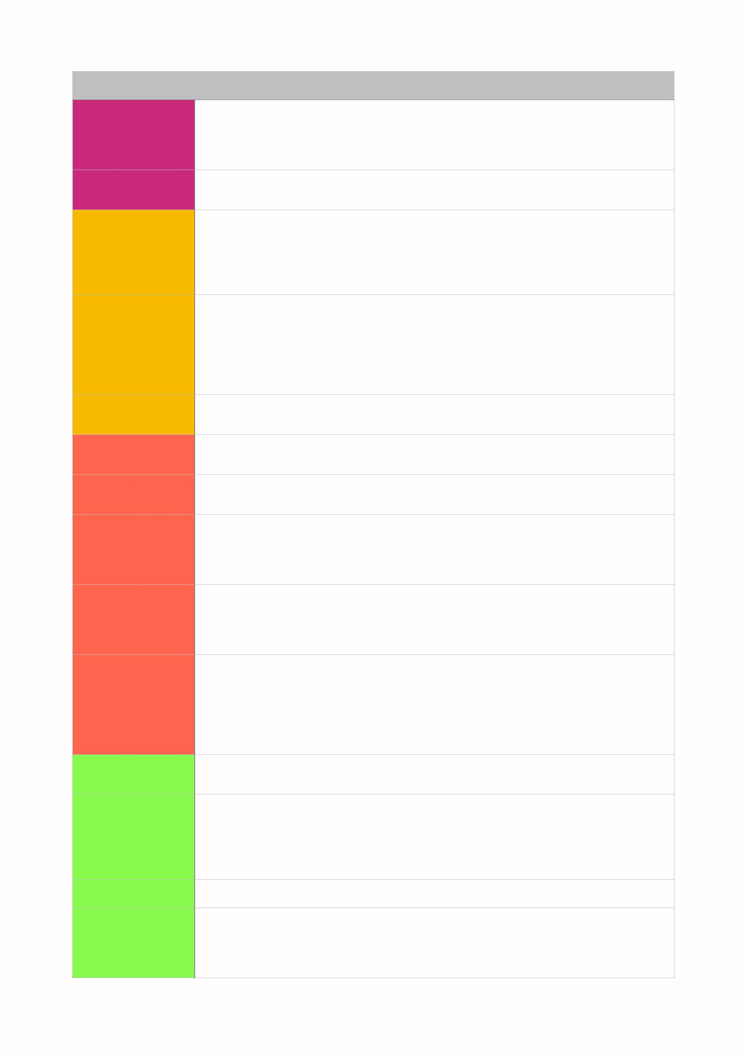
6.61.01 Have you ever had a pet? What was it? How long did you have it for?
Why do you think people keep unusual pets?
Do you think pets serve a useful function?
Do you think some people get too attached to their pets?
6.64.05.b/d Do you ﬁnd it diﬃcult to say no?
What sort of requests get on your nerves?
7.75.Speaking. What do you think were the top scientiﬁc breakthroughs of the last century?
What do you think will be the top scientiﬁc breakthroughs of our present century?
Which of the past has had the biggest eﬀect on your life and lifestyle?
Which could you live without?
Which future breakthrough will have the greatest impact on life as we know it?
7.76.01 Discuss the future implications of :
getting a tattoo
leaving your job having plastic surgery dying your hair bright blue
Are you an impulsive decision maker?
7.77.05 How would you update the technology you use in your everyday life if money were
no object? What could you live without?
8.80.04a Do you think punishment is an eﬀective deterrent to crime? If yes…. If not….
8.81.L01 Have you ever had anything stolen? What was it? Did you get it back?
If you haven’t, what would cause you the most inconvenience if it was stolen? Why?
8.81.P03 Why is it important to read everything you sign?
When was the last time you signed an oﬃcial document? Are you sure you read it
all before signing?
Have you ever had to go to a Police Station? What for?
8.83.Speaking.  01a/c/d.02 |  | No one should work more than 32 hours a week  All major cities should provide free Wi-Fi access in all public places  Families should not be allowed to have more than one car  Are there any laws in China that you would like to change or introduce?
8.86.05 Break the following news
You’re quitting your job/studies and going to wrk for a charity in Africa.
Your granddad has just won one million in the lottery.
Your teacher has published a best-selling novel under a pseudonym.
The government is going to prohibit the use of mobile phones on public transport.
Your college has just announced they’re going to abolish written exams.
9.88.03 How does your energy pattern compare and ﬁt in with those of your friends or
family members?
9.89.02 What’s your favourite time of day?
When do you usually feel most and least alert?
What do you generally do ﬁrst thing in the morning and last thing at night?
When was the last time you got up at the crack of dawn?
Have you ever been woken up in the wee small hours / in the middle of the night?
9.90.01 How well do you sleep?
9.91.06 What advice would you give to one of these problems?
I keep oversleeping in the morning.
I’m always drowsy in the afternoon.
I always wake up a ﬁve in the morning and can’t get back to sleep.
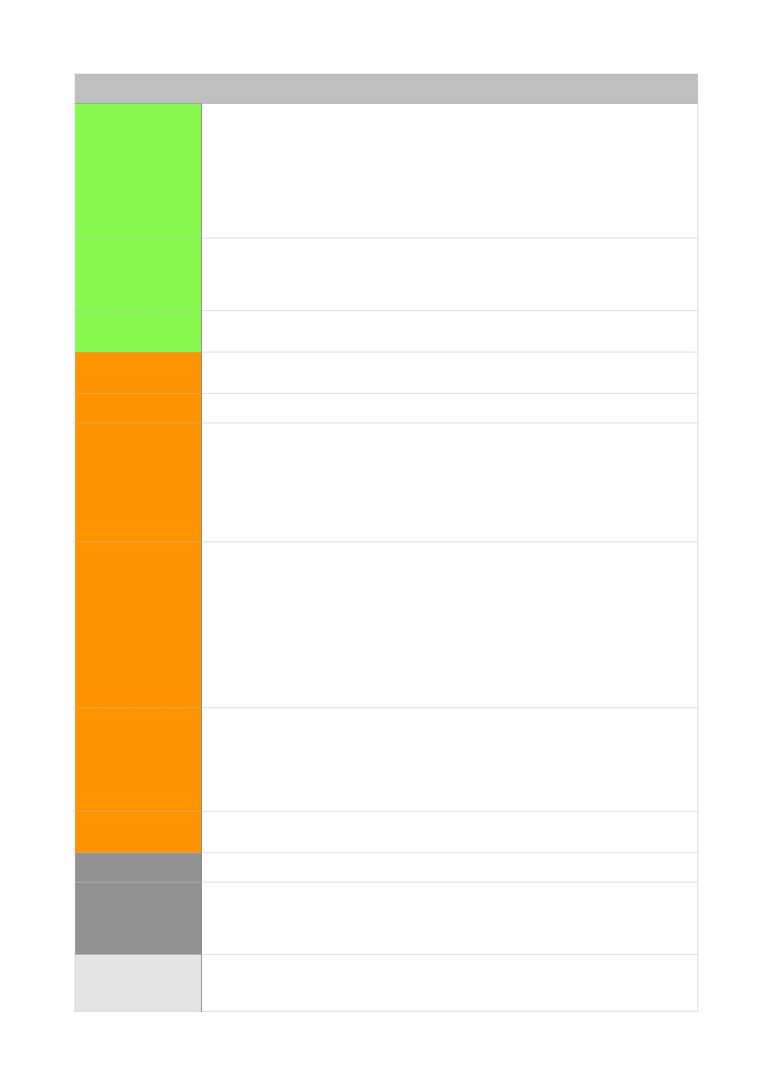
9.92.Speaking Where and when did the experience take place?
Why ddi you stay up all night?
Who were you with?
What happened during the night? What else did you see, hear or do?
What feelings did you experience?
How did you feel at the end of the night?
Was it a worthwhile experience?
9.93.V02 Imagine you’ve just passed your ﬁnal exams. Where would you go to have a night
on the town? Who would you invite? What would you do?
Imagine your best friend is getting married and has asked you to organise his/her
stag/hen night. What would you do?
9/95.LG05 Talk about a holiday you have been on. Express things you regret and things you
were glad about.
10.101.L02b Would you consider making any changes in your lifestyle to reduce your footprint?
Why? Why not?
10.102.05b Have you ever visited an important historical site? What were your impressions?
10.104.LS03 Would you like to try barefoot hiking? Why? Why not?
Imagine you are walking barefoot; describe what it would feel like, the dangers,
beneﬁts and disadvantages?
along a shallow stream in summer along the seashore through a snowy forest
in a grassy meadow
10.105.Speaking Where and when did you go on the walk?
Why did you go?
Had you done it before? Did you plan it? Were you alone?
What did you see, hear, feel or smell on the walk?
How long did it last?
How did you feel at the end?
What did you do after you arrived at the end?
10.105.V03.a/d/e/  g/h/k |  | When do you like to put your feet up?  Can you think of a time recently when you put your foot down?  When should children stand on their own two feet ﬁnancially, in your opinion?  Do you have itchy feet at the moment?  Have you ever got cold feet about a holiday or change in y our life?  Can you remember a situation in which you tried hard not to put a foot wrong?
10.106.04 Do you believe that you tell someone’s personalty from their shows?
What do you think your shoes say about you and your friends?
11.112.R01 Think of ﬁve tips you could give a person who wants to improve their writing
11.116.05 What’s your opinion?
Social networks are great - best way to keep in touch with friends
Face time with friends is really important
I’m tired of this always-on, always-connected lifestyle
12.118.V02 Do you often see people asking for money on the streets of your town?
Are they tolerated or do the police tend to move them on?
What do you think is the best way to help people who ask for money on the streets?

12.121.04 Order the following according to their importance in your opinion for a happy and
fulﬁlled life.
a good education; a good job; getting on with family; good self-esteem Can any exist with the other three?
12.123.02/03 What would give you a guilty conscience?
smoking in an enclosed place?
throwing litter on the ﬂoor? spending money on luxury items?
eating too much chocolate? forgetting someone’s birthday?
not doing your homework?
losing your temper with someone?
not keeping your promise? keeping people waiting? forgetting to water the plants?
What did you do to make amends?
12.124.05.a/b/c What would you say? How angry would they be?
borrowed someone’s bike and damaged it
lost your friend’s memory stick spilt drink over a stranger
12.124.07 When was the last time someone apologised to you?
What were they apologising for?
How did they apologise?
Did you accept their apology? Why? Why not?

